# Setting up Application Environment Create Sendgrid Account

|  |  |
| --- | --- |
| Date | 29 October 2022 |
| Team ID | PNT2022TMID23044 |
| Project Name | Skill/Job Recommender Application |

**Step 1.** Navigate to https://sendgrid.com

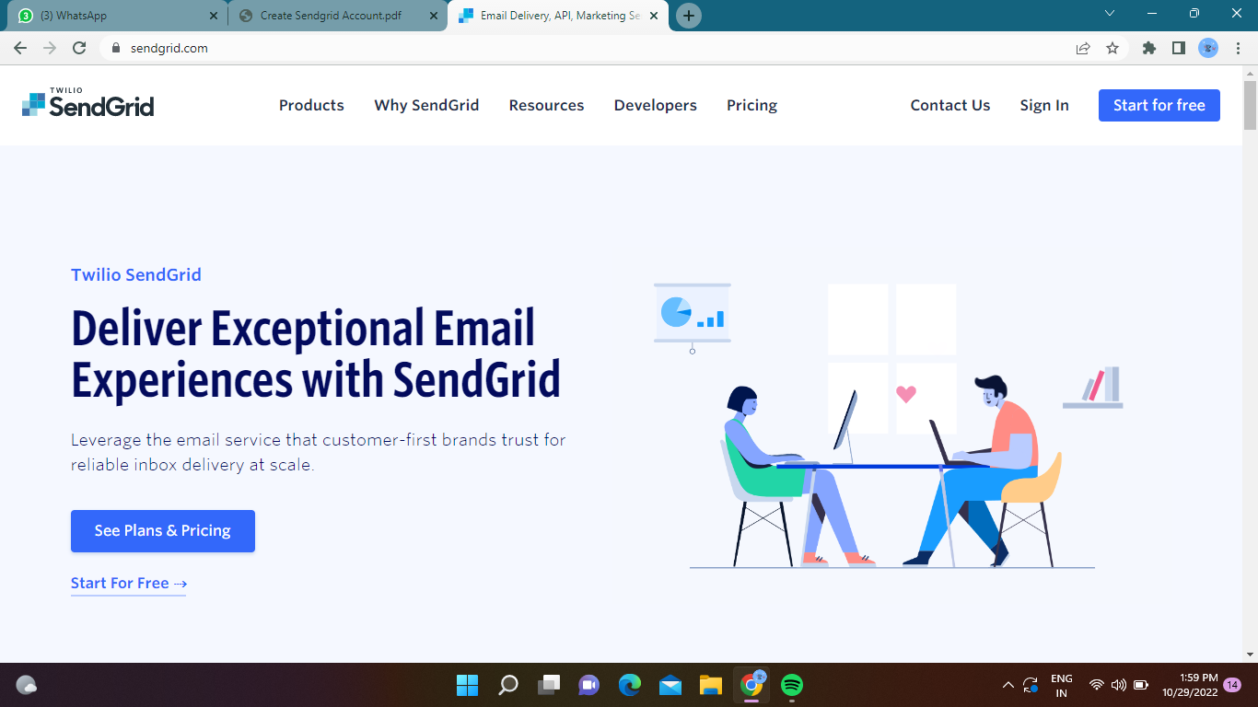

**Step 2.** Click on “Start for free” and register yourselves by entering required details and click on create account

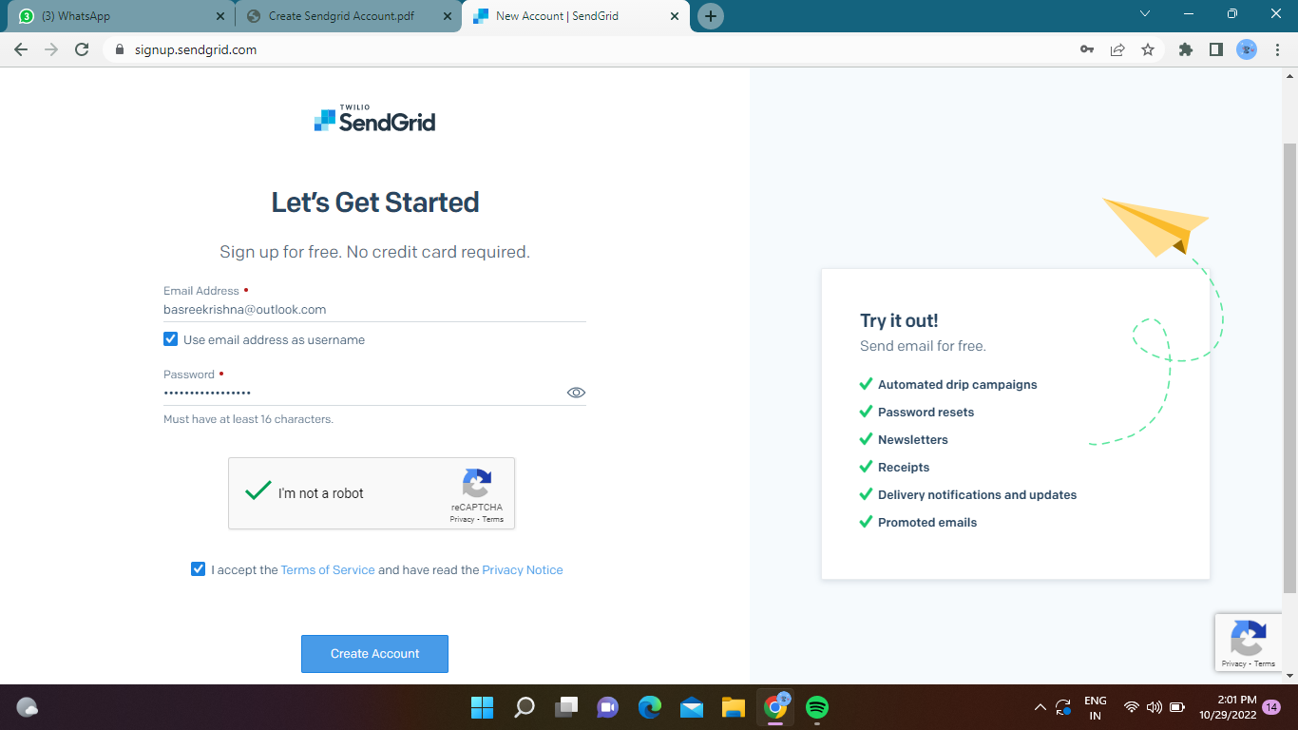

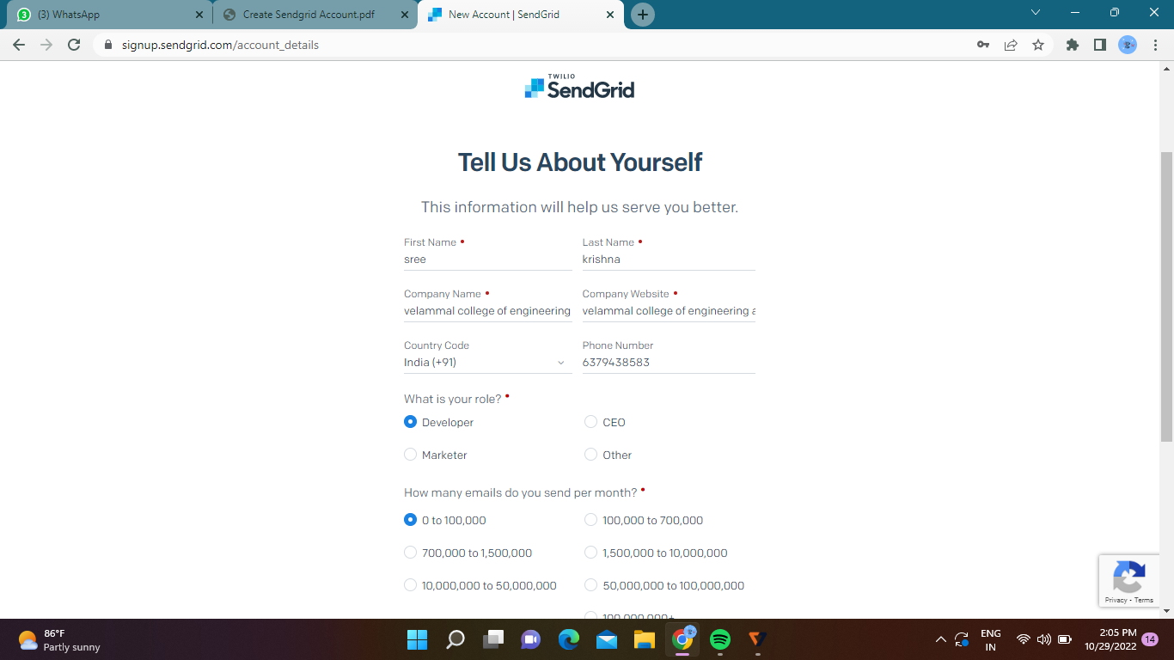

**Step 3.** Further fill all required details in next page and click on get started as shown below

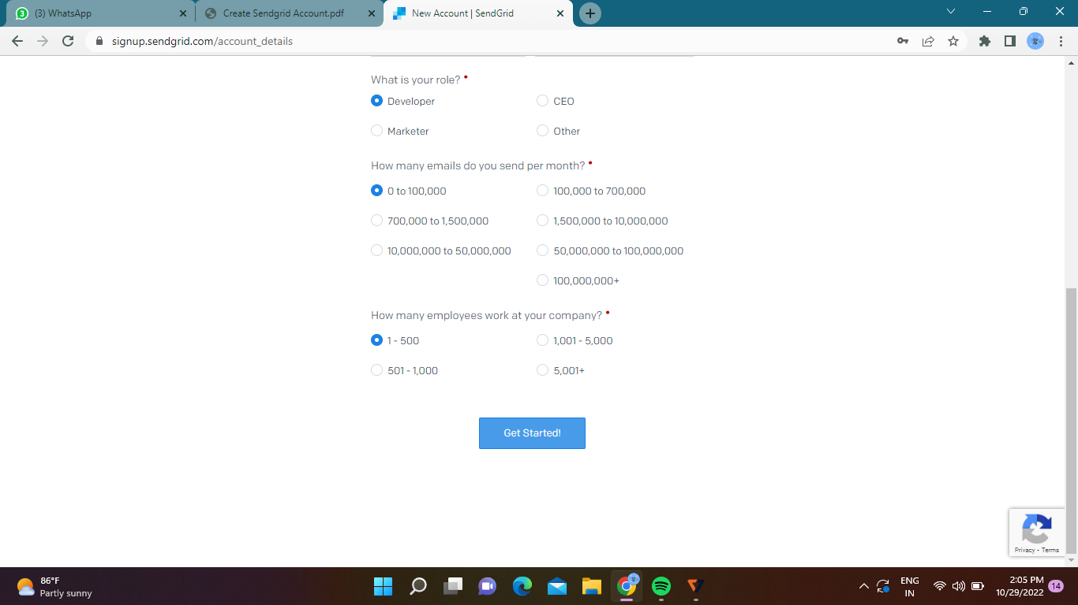

**Step 4.** That’s it you have created your SendGrid account and got access to dashboard

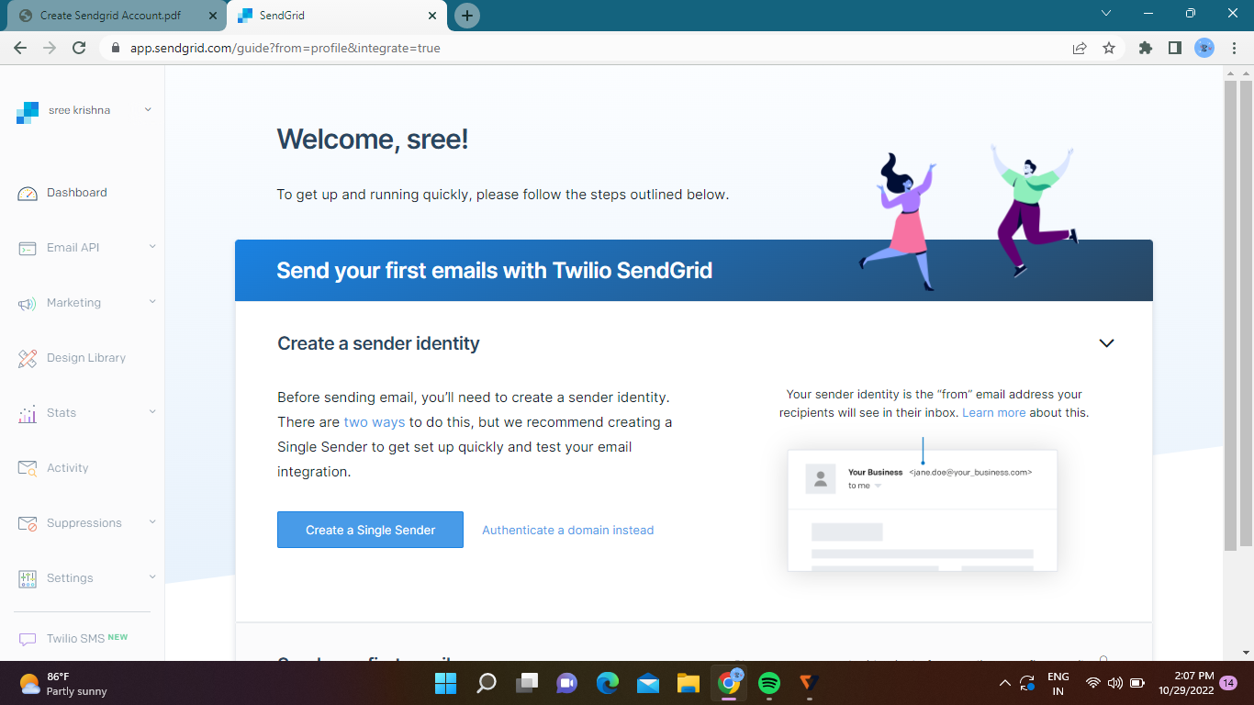

# Output:

Send Grid account created successfully.